**SonarQube Static Scan**

Github Repo: <https://github.ibm.com/modern-poc/java-k8s-cicd-test-cdt/tree/develop-s209>

Insight toolchain: <https://cloud.ibm.com/devops/insights/qualitydashboardNew?toolchainId=9c478366-cdf6-490d-9983-f9748c13a129>

CI toolchain: <https://cloud.ibm.com/devops/pipelines/5fd743f9-3dc4-440c-b3fc-838d6e3dbf96?env_id=ibm:yp:us-south>

Pipeline Image for SonarQube scan: **2.7**

**Source Code changes**

Below files are to be updated to incorporate sonarqube changes

* pom.xml: to add dependencies to sonarqube & jacoco plugin.
* Pipeline.config: sonarqube configurations

**Pom.xml**

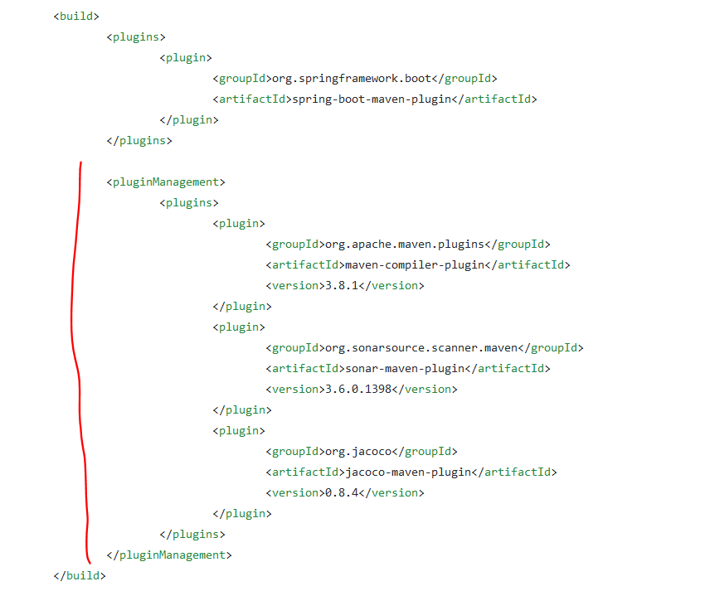

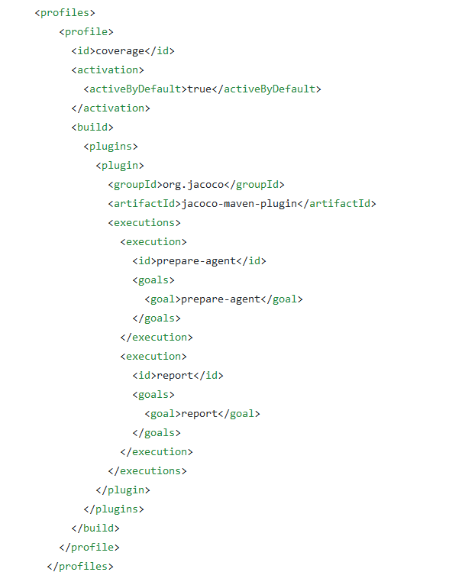

**Pipeline.config**

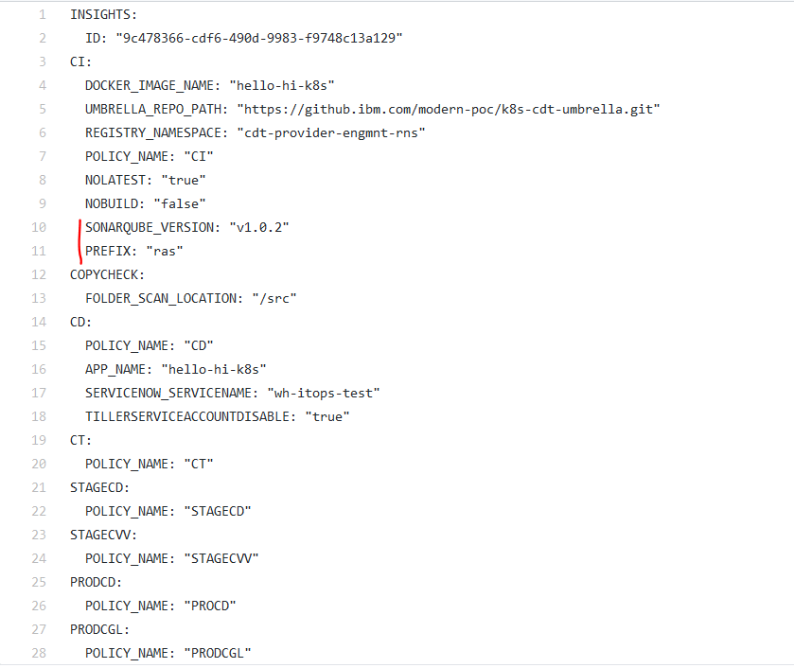

**CI pipeline configurations**

Under Actions… > Configure Pipeline, add ARTIFACTORY details

ARTIFACTORY_URL: <https://na.artifactory.swg-devops.com/artifactory/wh-code-all-maven-virtual/>

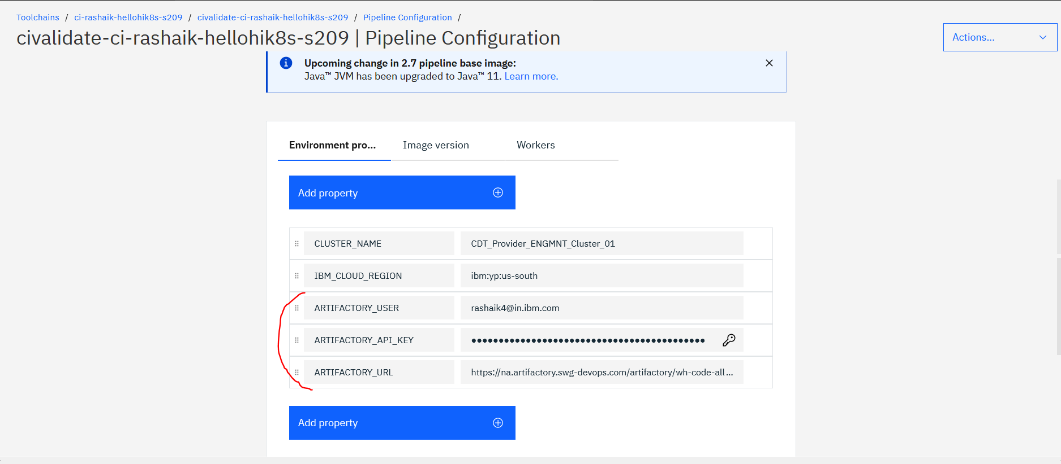

Once the scan executed successfully, you can see the results in the Insights dashboard

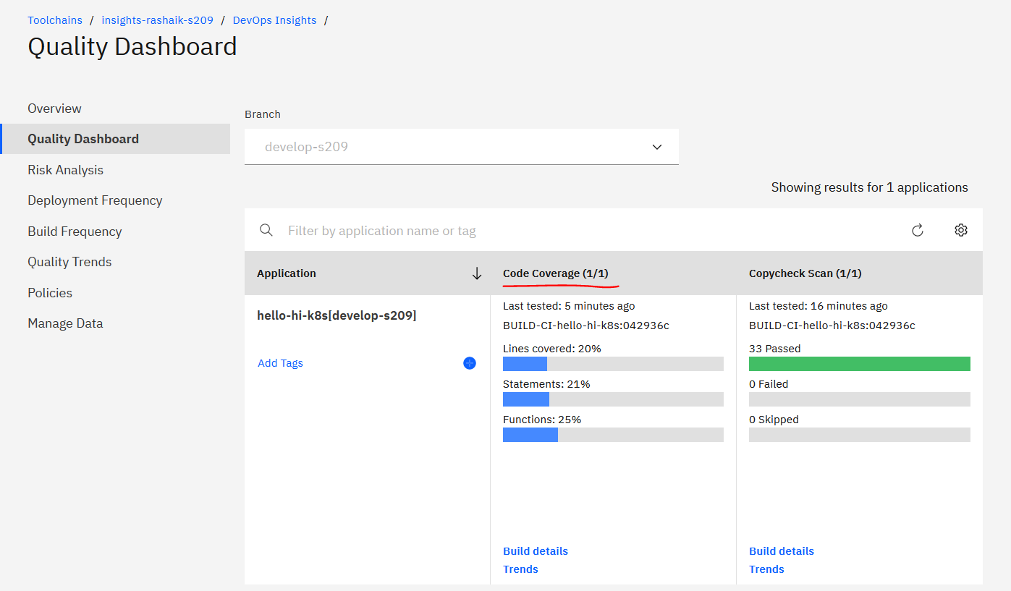

Also if you want to view the SonarQube UI, see the Sonarqube job’s logs below

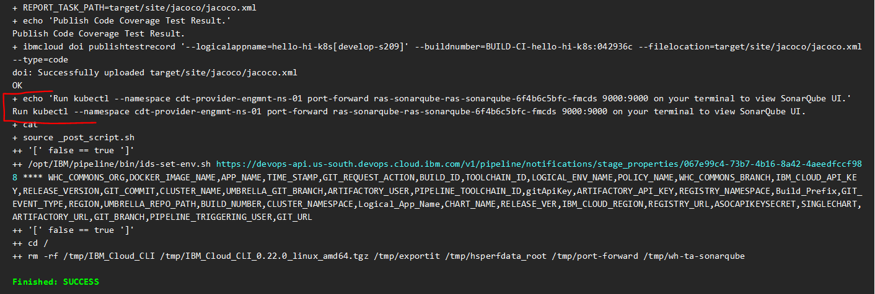

Run the port-forward on the pod as given in the log



Now, open browser and enter the url – <http://localhost:9000>

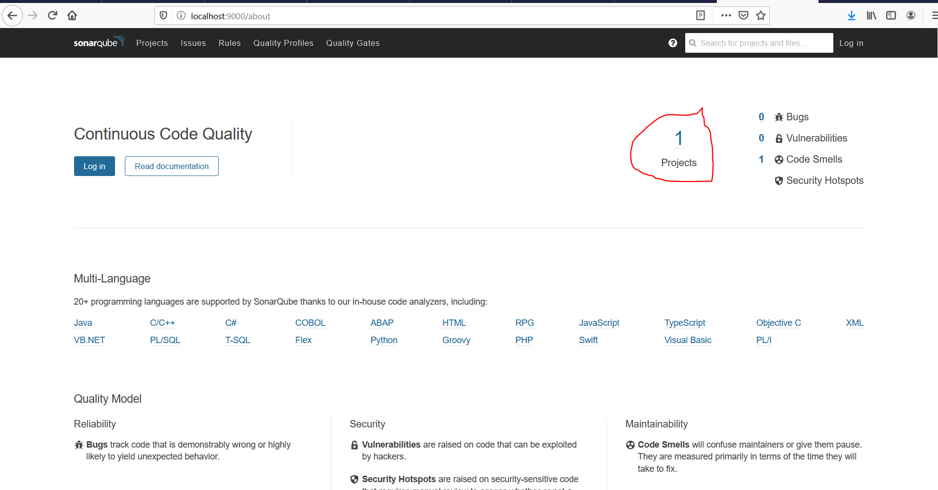

Click on “1 projects”

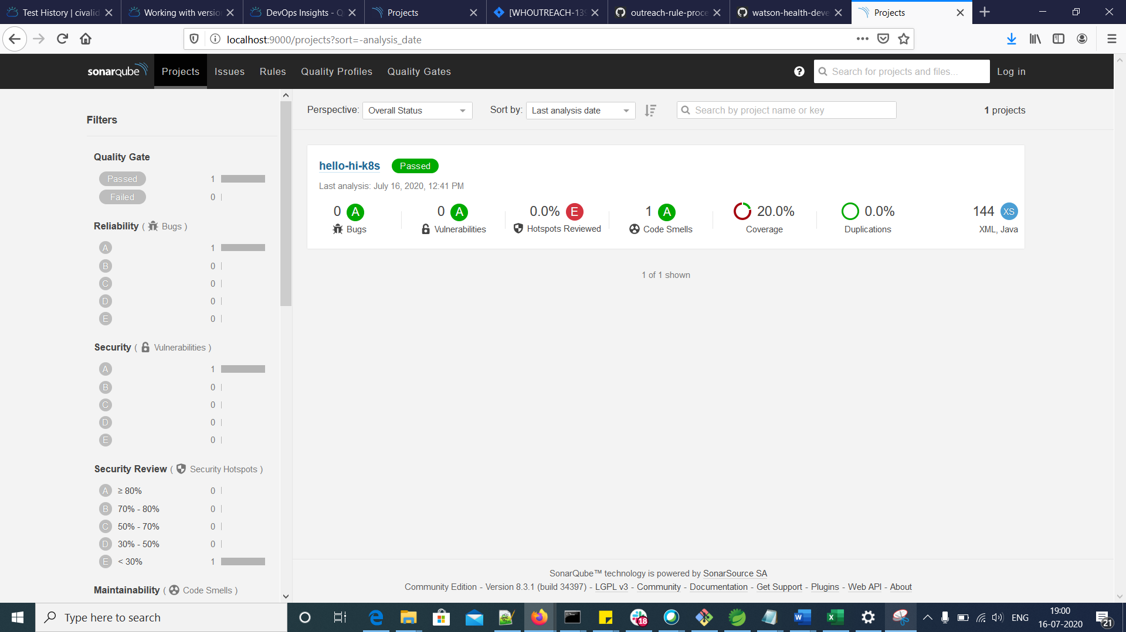

Also, you can see logs related to PostgresDB and SonarQube installation at the beginning on the logs.

Enter the below command to list down the pods in Command prompt

$ kubectl get pods -n cdt-provider-engmnt-ns-01 | findstr ras-sonar



“ras” is the prefix given in pipeline.config. There are 2 pods available - one for Postgress and the other Sonarqube.

Reference:

<https://github.ibm.com/watson-health-development/wh-ta-sonarqube>

<https://github.com/SonarSource/sonar-scanning-examples/tree/master/sonarqube-scanner-maven>

<https://github.com/SonarSource/sonar-scanning-examples/tree/master/sonarqube-scanner-maven/maven-multimodule#description>

<https://docs.sonarqube.org/latest/analysis/scan/sonarscanner-for-maven/>